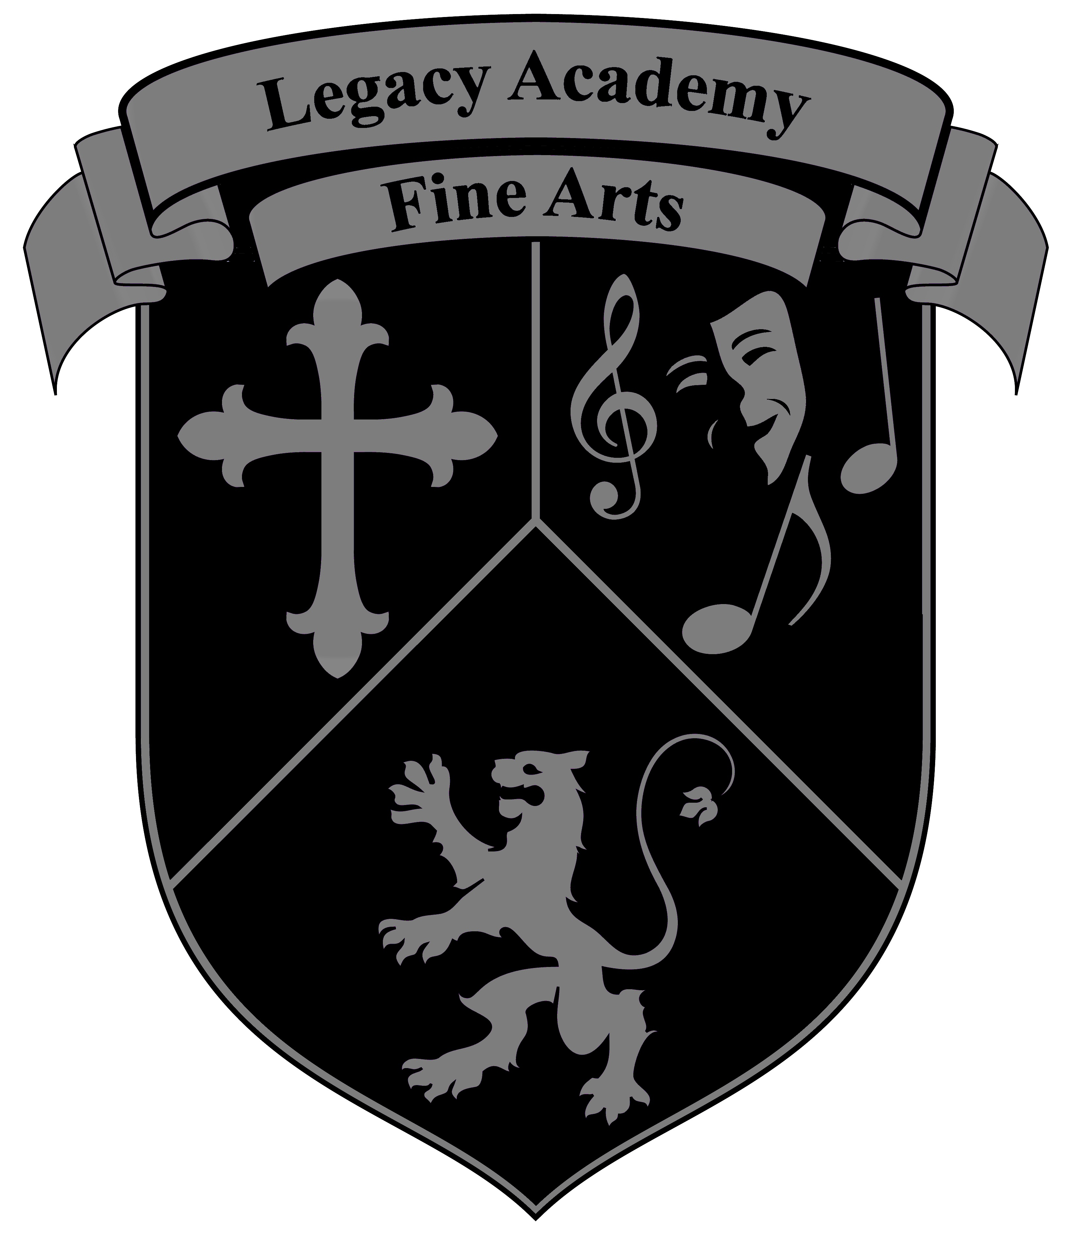
Legacy Academy Fine Arts

2023-2024 Class Schedule
Middle/Highschool Guitar: Ms. Koltvedt
Monday | Tuesday | Wednesday | Thursday | Friday
 | 3:15 – 4:15  Lauren Koltvedt  Guitar  North Campus Music Classroom |  | 3:15 – 4:15  Lauren Koltvedt  Guitar  North Campus Music Classroom
Intermediate/Advanced Choir: Mrs. Romero
3:15 – 4:15  Mrs. Romero  Inter/Adv. Choir  North Campus Choir Room | 3:15 – 4:15  Mrs. Romero  Inter/Adv. Choir  North Campus Choir Room
Elementary Dance: Mrs. Rhodes
 | 3:30 – 4:30  Mrs. Rhodes  Beginning Dance  South Campus Music Room |  | 3:30 – 4:30  Mrs. Rhodes  Beginning Dance  South Campus Music Room
Beginning/Intermediate Orchestra: Ms. Kentla
3:30 p.m. – 4:30 p.m.  Orchestra I  Central Campus  Kentla’s 2nd Grade Classroom | 3:30 p.m. – 4:30 p.m.  Orchestra II  TBD | 3:30 p.m. – 4:30 p.m.  Orchestra I  Central Campus  Kentla’s 2nd Grade Classroom | 3:30 p.m. – 4:30 p.m.  Orchestra II  TBD
Elementary Choir: Mr. Battke
 | 3:30 – 4:30  Mr. Battke  Choir  Central Campus  Battke’s 2nd Grade Classroom |  | 3:30 – 4:30  Mr. Battke  Choir  Central Campus  Battke’s 2nd Grade Classroom
Legacy Academy Fine Arts

2023-2024 Class Schedule
High School Drumline: TBD
Monday | Tuesday | Wednesday | Thursday | Friday
6:45 a.m. – 7:45 a.m.  TBD  Drumline  North Campus |  |  | 6:45 a.m. – 7:45 a.m.  TBD  Drumline  North Campus
Elementary Guitar: Mr. Battke
3:30 – 4:30  Mr. Battke  Guitar I  Central Campus  Battke’s 2nd Grade Classroom  4:30 – 5:30  Mr. Battke  Guitar II  Central Campus  Battke’s 2nd Grade Classroom |  | 3:30 – 4:30  Mr. Battke  Guitar I  Central Campus  Battke’s 2nd Grade Classroom  4:30 – 5:30  Mr. Battke  Guitar II  Central Campus  Battke’s 2nd Grade Classroom

Dear Parents and Students,
Legacy Academy offers many opportunities for students to grow and learn in fine arts. Our commitment to Christian values and a love of the arts results in a harmonious combination. In our programs, fine arts students will learn to expand their skills and recognize how their God-given talents can be used to glorify the Creator.
Before and after school fine arts classes are currently being offered in the following areas to those interested in playing an instrument or being involved in Fine Arts for Legacy Academy.

- Instructor: Ms. Kentla
Orchestra I: Beginning level class in violin, viola, cello, or double bass. No previous experience is required.
Orchestra II: Intermediate/Advanced class in violin, viola, cello, or double bass. At least one year of previous study is required.
(Orchestra I and II are based on ability level, not grade level.)

- Instructor: Ms. Rhodes
Elementary Dance: Beginning level dance course emphasizing ballet and fundamental technique. Open to elementary students.
- Instructor: Mr. Battke
Elementary Guitar I: Beginning level class for guitar. No previous experience is required.
Elementary Guitar II: Intermediate/Advanced class. At least one year of previous study is required.
Elementary Choir

- Instructor: Ms. Koltvedt
Middle/High School Guitar: Class for North Campus students covering fundamentals of
musical technique and performance on the Guitar.

- Instructor: Mrs. Romero
Middle/High School Choir: Class for North Campus students focusing on vocal performance.

- Instructor: TBD
High School Drumline: Before school, percussion drumline class.

Course-specific information and concert dates will be given to students when classes start. For 2023-2024 billing dates, please see Fine Arts Contract. Fine Arts Classes begin the week of August 21, 2023. For private lessons or more information, please get in touch with Ms. Kentla at mkentla@legacyacademynm.com

Ms. Kentla - Fine Arts Director

Ephesians 5:19 - Speak to one another with psalms, hymns, and songs from the Spirit. Sing and make music from your heart to the Lord.

